MarineGEO Temperature Logger Protocol

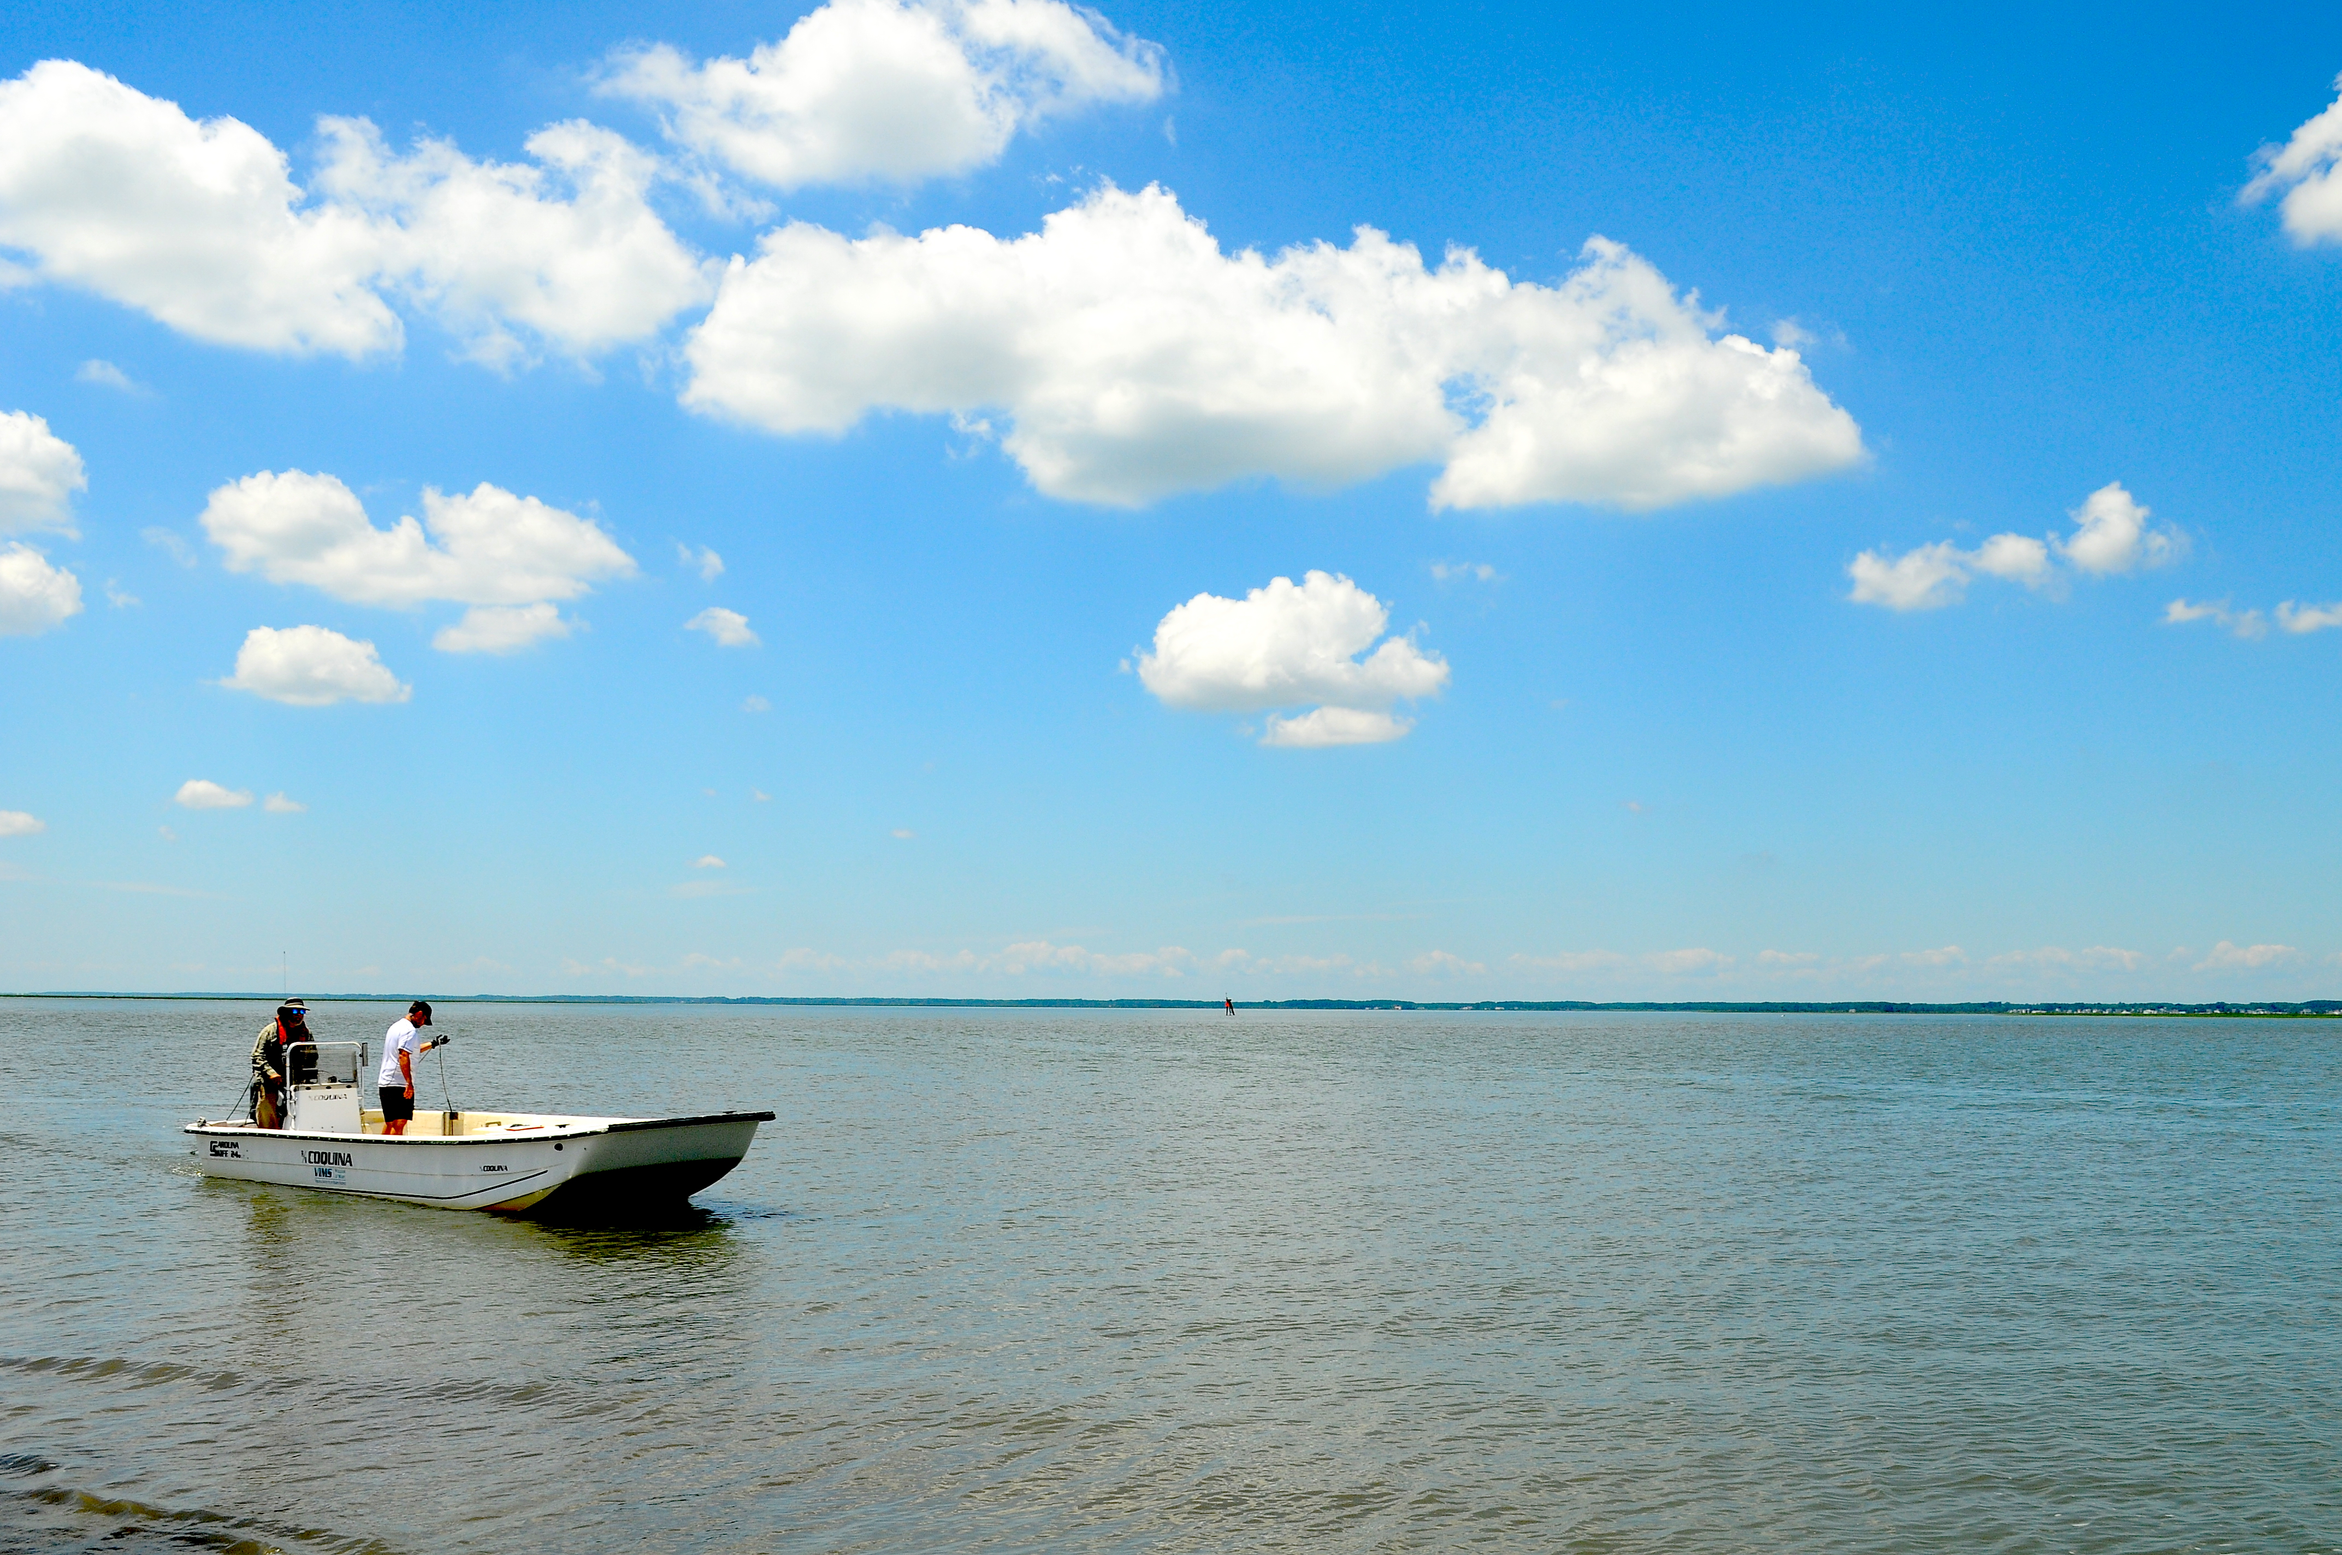

How to cite this work: MarineGEO Temperature Logger Protocol. (2022) Harper, Leah, Tennenbaum Marine Observatories Network, MarineGEO, Smithsonian Institution. https://doi.org/10.25573/serc.19153766.v3

## Introduction

Use this protocol to deploy temperature loggers to track temperature throughout the year.

## Measured Parameters

Water temperature

## Requirements

Number of Personnel: 1-2 people

Estimated Total Time Per Location:

Preparation: 1 person x 0.5 hours

Field work: 1 person x 0.25 hours

Post-processing: None

Data processing: 1 person x 0.5 hours

## Materials:

* Clipboard with datasheet on waterproof paper
* Pencil
* Hand-held GPS
* 2 EnvLogger temperature loggers (per sampling location)
* Smartphone with EnvLogger application downloaded (for data retrieval)

## Methods

Fully review this and any additional protocols necessary for the sampling excursion. Address any questions or concerns to [marinegeo-protocols@si.edu](mailto:marinegeo-protocols@si.edu) before beginning this protocol.

**Preparation:**

1. Use the EnvLogger App to name your loggers with a unique identifier.

2. Label the plastic casings of your EnvLogger temperature loggers with the same unique identifiers.

3. Record the logger names and serial numbers on the EnvLogger Deployment field sheet.

4. In the EnvLogger App, set your loggers to start their missions around the time you plan to deploy.

* + Set loggers to record at **two-hour** intervals, with time set to Coordinated Universal Time (UTC).
  + Set loggers to record at **0.5°C resolution.**
  + Select the “pretty dates” option, which will log on the hour. See EnvLogger handbook for more detailed instructions:

<https://marinegeo.github.io/assets/environmental-monitoring/envlogger_documentation.pdf>

**Fieldwork:**

**EnvLogger Deployment**

1. Record site metadata on the EnvLogger Deployment field sheet.
2. Locate permanent transect markers.
3. Deploy two EnvLogger temperature loggers, one each at opposite ends of the site. Loggers should be secured at least 30cm from the substratum and in a location you will be able to easily relocate. Attaching the loggers to permanent transect markers is recommended.
   1. Record latitude and longitude of logger locations on field sheet in decimal degrees
   2. Record the depth (m) of the logger on the field sheet

**After Deployment**1. Enter all relevant metadata to your EnvLogger Deployment spreadsheet.   
2. Complete and submit a new EnvLogger Deployment spreadsheet when:

* Deploying temperature loggers at a new location
* Deploying a new temperature logger (e.g. previously unrecorded serial number)
* Moving an existing temperature logger to a new location

**EnvLogger Retrieval**

1. EnvLoggers should remain at each site year-round
2. If possible, download temperature data quarterly
   1. Bring your logger to the surface. Use the EnvLogger App to retrieve data.
   2. Remove any fouling material on your logger.
   3. Return your logger to its location
3. Using the EnvLogger application, email the data to yourself. Alternatively, move the data from your smartphone to a laptop or PC using another method, such as Bluetooth, Dropbox, iCloud, etc. Contact marinegeo-data@si.edu if you have any issues extracting the data from your device.
4. After one year has passed, replace each logger with a new logger when downloading temperature data.

## Data Submission

1. Scan the completed field data sheets and save both paper and electronic versions locally. We do not require you to submit the scanned forms.
2. Enter data into the provided data entry template. Each template is an Excel spreadsheet. Please provide as much protocol and sample metadata as possible. Use the “notes” columns to provide additional information or context if a relevant column doesn’t already exist, rather than renaming or creating columns.
3. Use our online submission portal to upload the logger data (.csv file extension) and data entry spreadsheet (.xlsx file extension): <https://marinegeo.github.io/data-submission>
4. Have HOBO logger data instead? We accept it! Please email it to: marinegeo-data@si.edu
5. Contact us if you have any questions: [marinegeo-protocols@si.edu](mailto:marinegeo-protocols@si.edu)